1-Abstract Classes

📌 Definition:
# Source: AI Source: Provided by: [Data Path: Persons Table -> ID Column: 1, Name_En Column: Motasem Essam] -> From: [Chatgpt (GPT‑5 Mini)] on [12/9/2025]
An abstract class is a class that cannot be instantiated (you cannot create objects from it) and is used to define a common base with shared behavior and abstract methods for its subclasses.

🧠 Simple idea:
# Source: AI Source: Provided by: [Data Path: Persons Table -> ID Column: 1, Name_En Column: Motasem Essam] -> From: [Chatgpt (GPT‑5 Mini)] on [12/9/2025]
Abstract Class = “Template with incomplete methods” 🧩

🔍 Key characteristics:
# Source: AI Source: Provided by: [Data Path: Persons Table -> ID Column: 1, Name_En Column: Motasem Essam] -> From: [Chatgpt (GPT‑5 Mini)] on [12/9/2025]
- ❌ Cannot create objects directly
- 📌 Can contain abstract methods (no implementation)
- 📌 Can also contain concrete methods (with implementation)
- 🔗 Used as a base class for inheritance
- 🧩 Helps achieve abstraction

📌 Example (Java):
# Source: AI Source: Provided by: [Data Path: Persons Table -> ID Column: 1, Name_En Column: Motasem Essam] -> From: [Chatgpt (GPT‑5 Mini)] on [12/9/2025]
Abstract class:
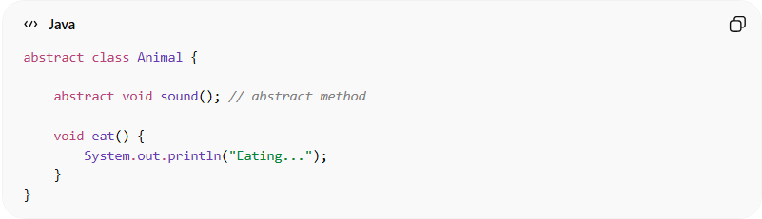
abstract class Animal {

abstract void sound(); // abstract method

void eat() {
System.out.println("Eating...");
}
}

Subclass:
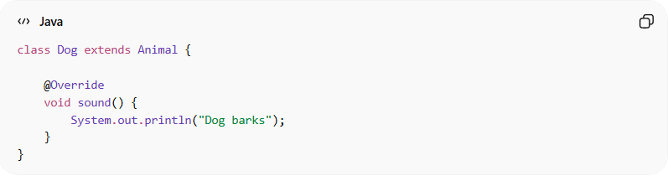
class Dog extends Animal {

@Override
void sound() {
System.out.println("Dog barks");
}
}

Usage:
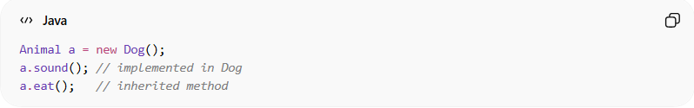
Animal a = new Dog();
a.sound(); // implemented in Dog
a.eat(); // inherited method

⚙️ When to use abstract classes:
# Source: AI Source: Provided by: [Data Path: Persons Table -> ID Column: 1, Name_En Column: Motasem Essam] -> From: [Chatgpt (GPT‑5 Mini)] on [12/9/2025]
- 🧩 When classes share common behavior
- 🔄 When you want to enforce certain methods in subclasses
- 🧠 When partial implementation is needed

🆚 Abstract Class vs Interface (quick idea):
# Source: AI Source: Provided by: [Data Path: Persons Table -> ID Column: 1, Name_En Column: Motasem Essam] -> From: [Chatgpt (GPT‑5 Mini)] on [12/9/2025]
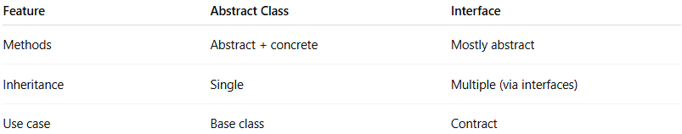
Feature | Abstract Class | Interface
Methods | Abstract + concrete | Mostly abstract
Inheritance | Single | Multiple (via interfaces)
Use case | Base class | Contract

🎯 Summary:
# Source: AI Source: Provided by: [Data Path: Persons Table -> ID Column: 1, Name_En Column: Motasem Essam] -> From: [Chatgpt (GPT‑5 Mini)] on [12/9/2025]
Abstract classes provide a base structure with shared and incomplete functionality, allowing subclasses to implement specific behavior while reusing common code.

2-Abstract methods

📌 Definition:
# Source: AI Source: Provided by: [Data Path: Persons Table -> ID Column: 1, Name_En Column: Motasem Essam] -> From: [Chatgpt (GPT‑5 Mini)] on [12/9/2025]
An abstract method is a method declared without implementation in a class (usually an abstract class), which must be implemented by its subclasses.

🧠 Simple idea:
# Source: AI Source: Provided by: [Data Path: Persons Table -> ID Column: 1, Name_En Column: Motasem Essam] -> From: [Chatgpt (GPT‑5 Mini)] on [12/9/2025]
Abstract Method = “Defined but not done” ⚡
- Specifies what to do
- Leaves how to do it to the subclass

🔍 Key characteristics:
# Source: AI Source: Provided by: [Data Path: Persons Table -> ID Column: 1, Name_En Column: Motasem Essam] -> From: [Chatgpt (GPT‑5 Mini)] on [12/9/2025]
- ❌ Has no method body
- 📌 Declared with the keyword abstract (in languages like Java)
- 🔗 Exists only in abstract classes or interfaces
- 🔄 Subclasses must implement it
- 🧩 Helps achieve abstraction and polymorphism

📌 Example (Java):
# Source: AI Source: Provided by: [Data Path: Persons Table -> ID Column: 1, Name_En Column: Motasem Essam] -> From: [Chatgpt (GPT‑5 Mini)] on [12/9/2025]
Abstract class with abstract method:
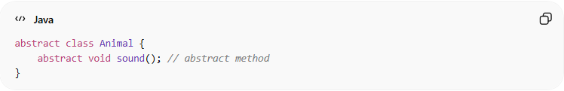
abstract class Animal {
abstract void sound(); // abstract method
}

Subclass implementing abstract method:
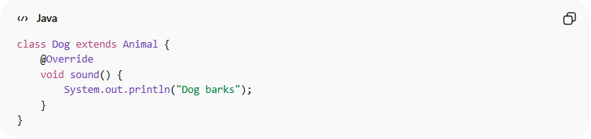
class Dog extends Animal {
@Override
void sound() {
System.out.println("Dog barks");
}
}

Usage:
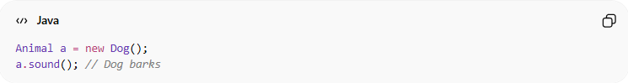
Animal a = new Dog();
a.sound(); // Dog barks

⚙️ Why abstract methods are important:
# Source: AI Source: Provided by: [Data Path: Persons Table -> ID Column: 1, Name_En Column: Motasem Essam] -> From: [Chatgpt (GPT‑5 Mini)] on [12/9/2025]
- 🧩 Forces subclasses to provide behavior
- 🔒 Ensures standardized interfaces
- 🧠 Supports polymorphism
- ⚙️ Useful in frameworks and APIs to define contracts

🆚 Abstract Method vs Concrete Method:
# Source: AI Source: Provided by: [Data Path: Persons Table -> ID Column: 1, Name_En Column: Motasem Essam] -> From: [Chatgpt (GPT‑5 Mini)] on [12/9/2025]
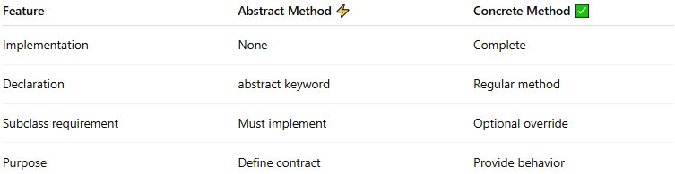
Feature | Abstract Method ⚡ | Concrete Method ✅
Implementation | None | Complete
Declaration | abstract keyword | Regular method
Subclass requirement | Must implement | Optional override
Purpose | Define contract | Provide behavior

🎯 Summary:
# Source: AI Source: Provided by: [Data Path: Persons Table -> ID Column: 1, Name_En Column: Motasem Essam] -> From: [Chatgpt (GPT‑5 Mini)] on [12/9/2025]
Abstract methods define a blueprint for behavior without implementation, requiring subclasses to provide the concrete functionality.

